Project Design Phase-II
Technology Stack (Architecture & Stack)

Date | 03 October 2023
Team ID | NM2023TMID00044
Project Name | Quantitative Analysis of Candidates in 2019 Lok Sabha Elections
Maximum Marks | 4 Marks

Technical Architecture:

Guidelines:
- Include all the processes (As an application logic / Technology Block)
- Provide infrastructural demarcation (Local / Cloud)
- Indicate external interfaces (third party API’s etc.)
- Indicate Data Storage components / services
- Indicate interface to machine learning models (if applicable)
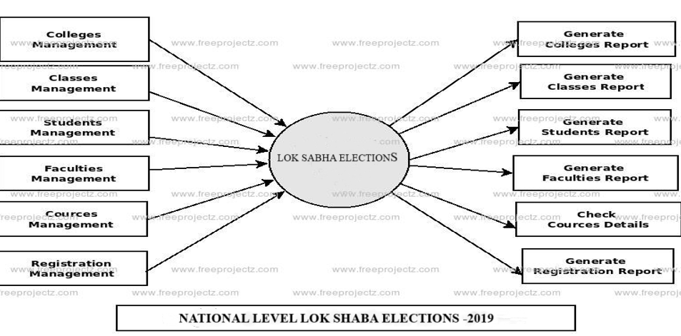

Table-1 : Components & Technologies:
S.No | Component | Description | Technology
1. | User Interface | How user interacts with application e.g. Web UI, Mobile App, Chatbot etc. | HTML, CSS, JavaScript / Angular Js / React Js etc.
2. | Application Logic-1 | Logic for a process in the application | Java / Python
3. | Application Logic-2 | Logic for a process in the application | IBM Watson STT service
4. | Application Logic-3 | Logic for a process in the application | IBM Watson Assistant
5. | Database | Data Type, Configurations etc. | MySQL, NoSQL, etc.
6. | Cloud Database | Database Service on Cloud | IBM DB2, IBM Cloudant etc.
7. | File Storage | File storage requirements | IBM Block Storage or Other Storage Service or Local Filesystem
8. | External API-1 | Purpose of External API used in the application | IBM Weather API, etc.
9. | External API-2 | Purpose of External API used in the application | Aadhar API, etc.
10. | Machine Learning Model | Purpose of Machine Learning Model | Object Recognition Model, etc.
11. | Infrastructure (Server / Cloud) | Application Deployment on Local System / Cloud Local Server Configuration:  Cloud Server Configuration : | Local, Cloud Foundry, Kubernetes, etc.

Table-2: Application Characteristics:
S.No | Characteristics | Description | Technology
1. | Open-Source Frameworks | TensorFlow and PyTorch | Python
2. | Security Implementations | security / access controls implemented, use of firewalls etc. | e.g. SHA-256, Encryptions, IAM Controls, OWASP etc.
3. | Scalable Architecture | Justify the scalability of architecture (3 – tier, Micro-services) | Hadoop, Apache spark, NoSQL databases
S.No | Characteristics | Description | Technology
4. | Availability | Review the specific data analytics programs, degrees, and specializations offered by each university. | NumPy, Pandas, scikit-learn
5. | Performance | Examine the research opportunities available at each university, such as labs, centers, and projects related to data analytics | Tableau, Power BI

References:
https://c4model.com/
https://developer.ibm.com/patterns/online-order-processing-system-during-pandemic/ https://www.ibm.com/cloud/architecture https://aws.amazon.com/architecture
https://medium.com/the-internal-startup/how-to-draw-useful-technical-architecture-diagrams-2d20c9fda90d

